


El Corte Inglés / Credit Card ( send this document via email to Jolanta Bloszyk malagalarios@viajeseci.es )

First Name
Last Name
Services requested | Two-night accommodation at the hotel Don Curro
Check in date | 23 of November 2016
Check out date | 25 of November 2016
Total Amount | 85 x 2 = 170 euros

Credit card to charge: □ VISA □ MASTERCARD □ AMEX

Name:____________________________________________Card No:______________________________________________
Expiration Date:______________________________ CVV______________________________________

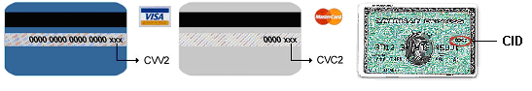
  - Number/Passport:___________________________

Total amount:____________________________€
Please, charge in my credit card the total amount indicated

Signature is required / Confirmation will be sent by mail

Any modification or cancellation of your booking may incur a penalty fee up to 100%

The personal details included in this document are of a confidential nature. In accordance with the Organic Law 15/1999, of 13 December, the holder of this data will be able to exercise his or her right of access, rectification and cancellation on written application to Viajes El Corte Inglés, S.A.; Servicios Centrales-Dpto. de organización y métodos; Avda. de Cantabria, 51; 28042 Madrid.

